HW4 report

Group 5

0516222 許芳瑀 0516209 呂淇安 0516326陳廷達

1. Introduction

The goal of this homework is using two pictures to reconstruct 3D model. In homework 3, we had learned the method of finding the same points in two pictures taken in different angles. In order to find fundamental matrix, we apply 8-points algorithm on previous points we found and ratio test. After getting fundamental matrix, we can calculate 4 possible essential matrices. The final step is examining 4 possible directions of camera, and then picking the best result with maximum number of points in front of camera.

1. Implementation procedure

(1) find out correspondence across images

This step is similar to hw3. The purpose is finding the corresponding points in 2 pictures. We use cv2 build-in function to reach the goal.

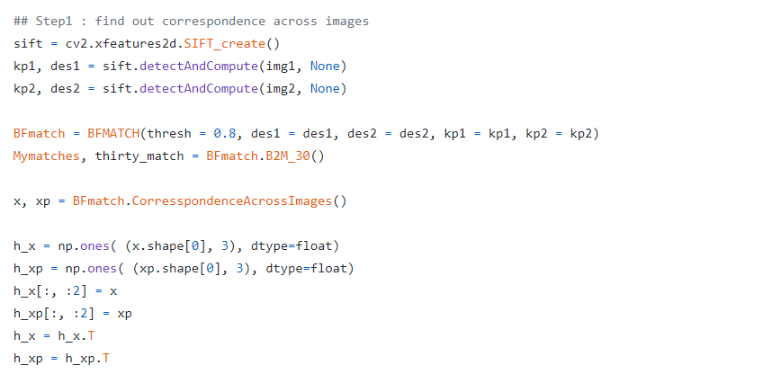

(2) estimate the fundamental matrix across images (normalized 8 points)

By step 1, we get x and x’. First we nnormorlize the points.

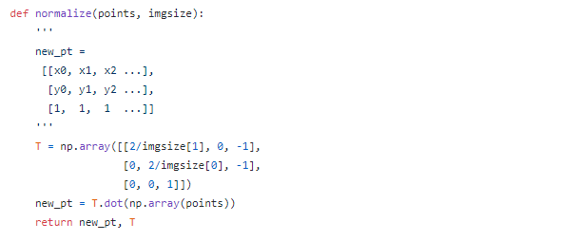

And then apply the RANSAC with 8-points algorithm. The fundamental matrix is deﬁned as x’ F x = 0. This can be written as

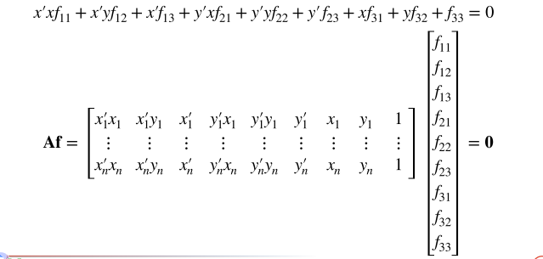

To solve the homogeneous linear equations, we use SVD

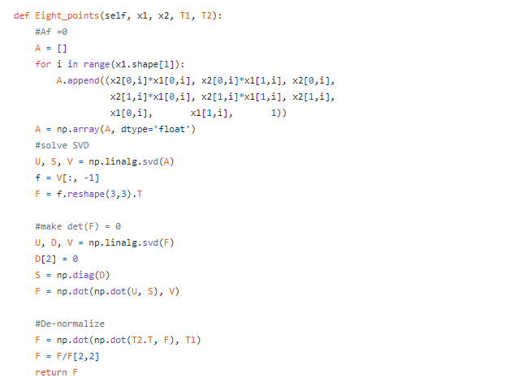

and calculate the error of F we found. And then keep the best result.

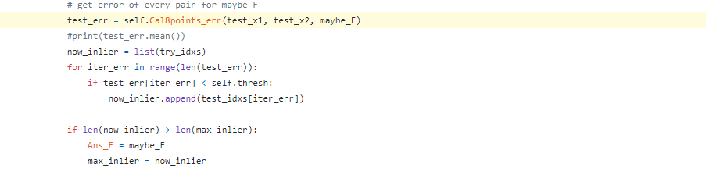

(3) draw the interest points on you found in step.1 in one image and the corresponding epipolar lines in another

By using fundamental matrix, the epipolar lines can be calculated as and . There are 3 parameters in l and l’, which means ax + by + c = 0. We assign x0 and y0 first, and then calculate and x1 and y1. By the two points we can draw a line.

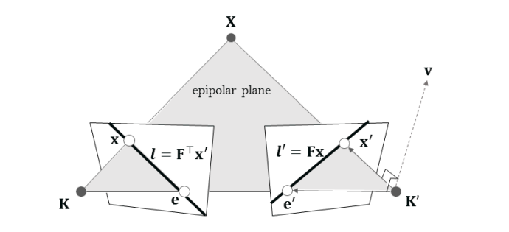

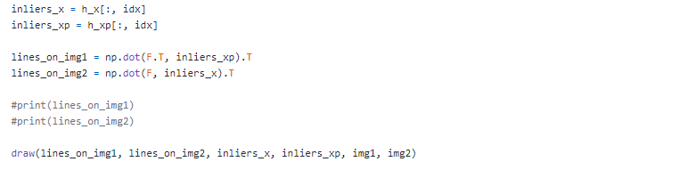

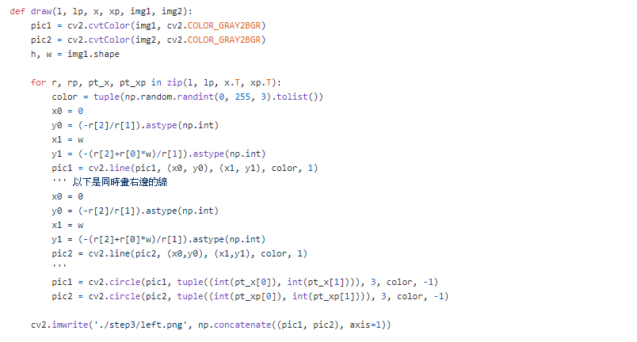

(4) get 4 possible solutions of essential matrix from fundamental matrix

Assuming first camera matrix is P1 = [ I | 0 ], there are four

possible choices for the second camera matrix P2. First we use intrinsic matrix K to get  and do SVD.

The possible P2 will be

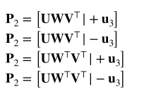

W is

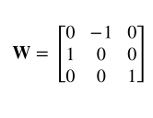

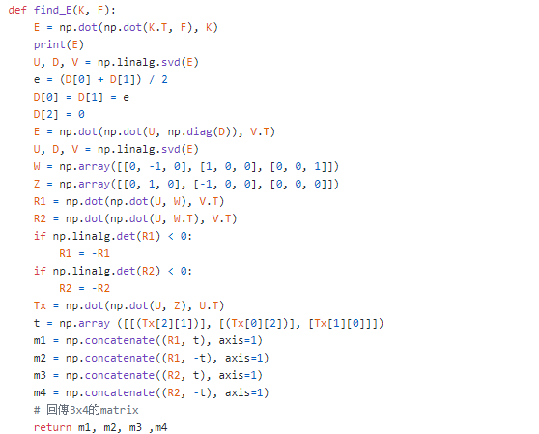

(5) apply triangulation to get 3D points & find out the most appropriate solution of essential matrix

With 4 possible camera matrix, we use triangulation to convert image points back to 3D coordinate.

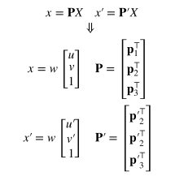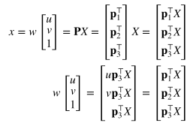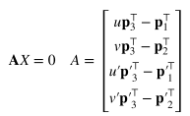

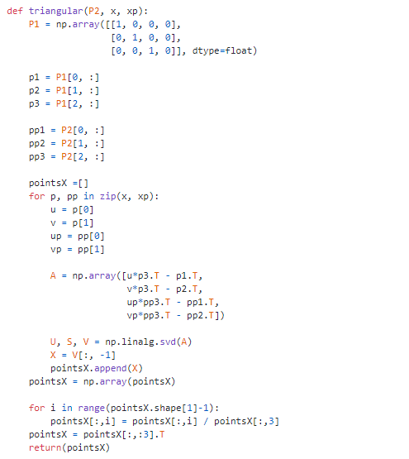

Next step is checking which solution will have maximum number of points in front of cameras.

The camera center is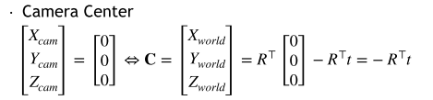

And the view direction is

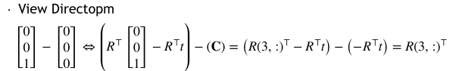

By performing this formula  we can know if the point is in front of camera. After doing the test of all points, we keep the best matrix to do next step.

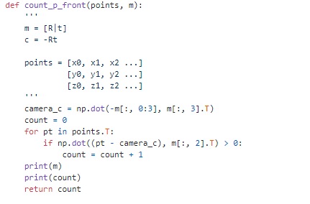

1. Experimental results (of course you should also try your own images)
2. Mesona

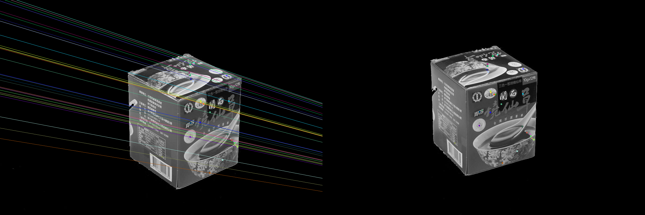

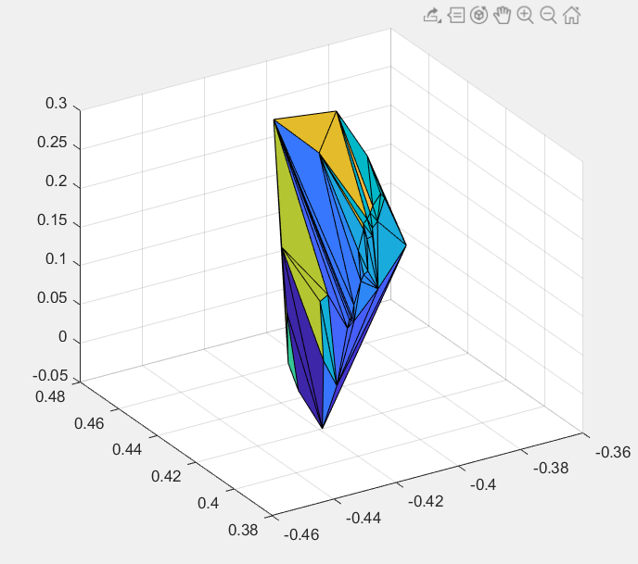

1. Statue  
   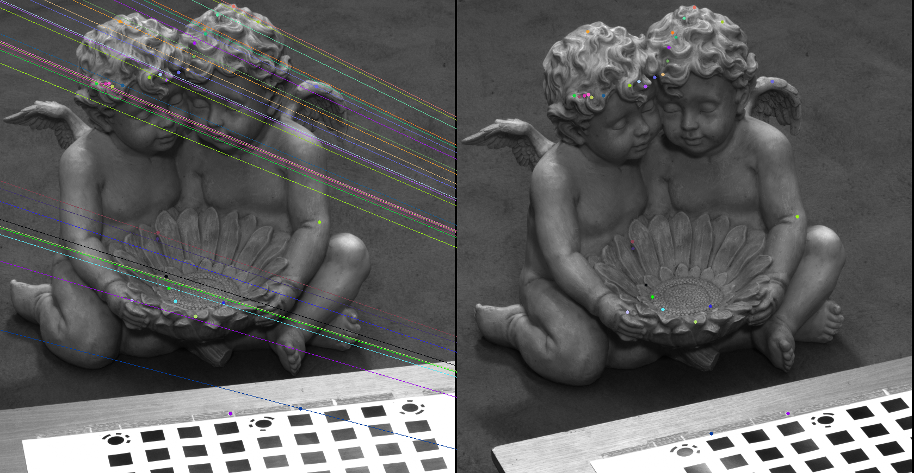  
   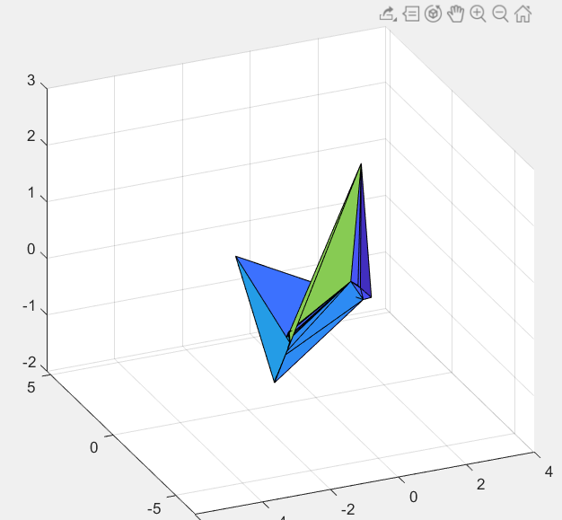
2. our picture

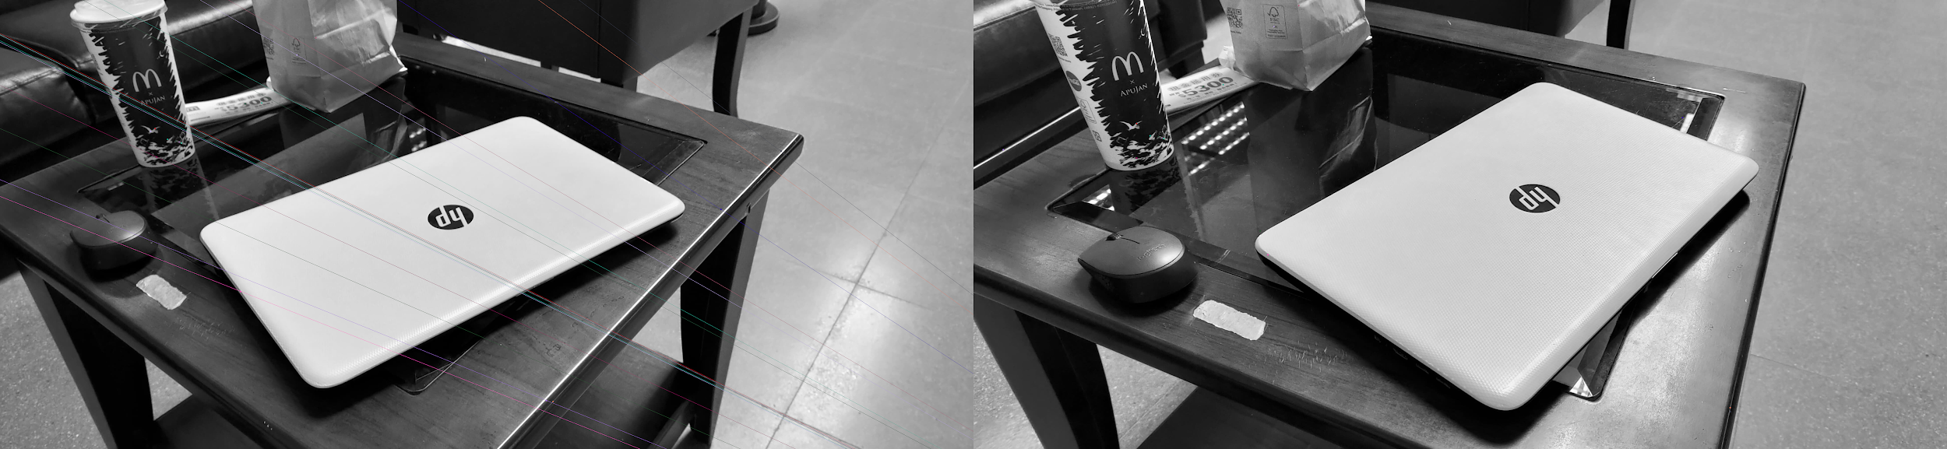

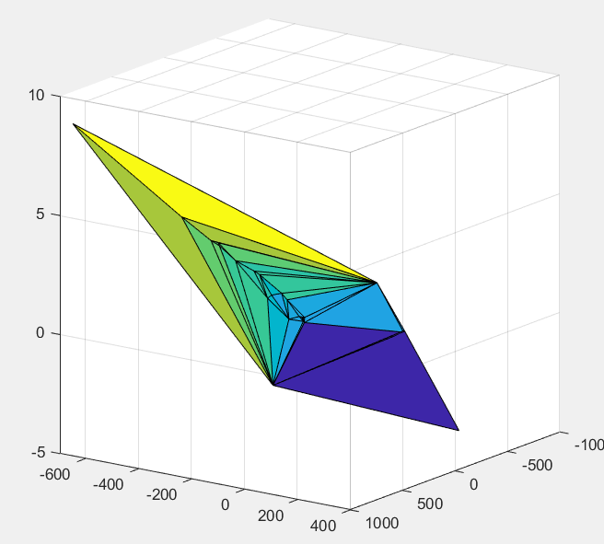

1. Discussion (what diﬃculties you have met? how you resolve them?)
2. When drawing the pictures (like step 3 and matlab), we didn’t know if our image is correct or not. So it is hard to debug or adjust our code.
3. There is an error in matlab code. We correct the file name in .mtl and the bug is fixed.
4. When doing matrix operations, some matrices need to be transposed first but some don’t need. The kind of problem confused us a little.
5. When calculating 8 points algorithm with RANSAC, we only take actually 8 points at first, but the outcome is not robust, so we increase the number of points we pick in one iteration.
6. Conclusion

After finishing this homework, we know more about the translation of 2D and 3D coordinates. The theory about image transform can be used in many applications. Though there are a lot of packages about SfM we can use, the experience of this homework will help us a lot in the future.

1. Work assignment plan between team members.

陳廷達:33%

許芳瑀:33%

呂淇安:33%